ViewMax™Liquid

by Toffeln

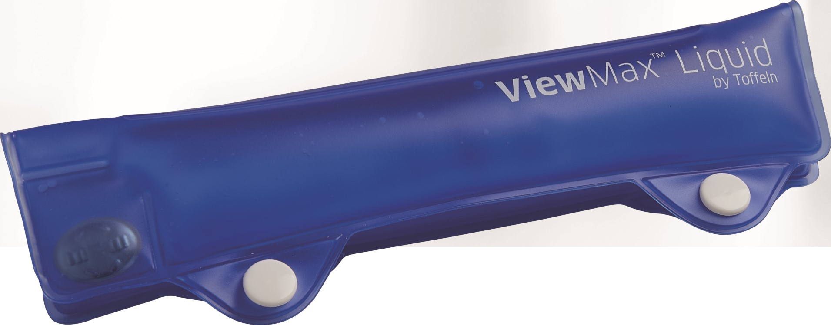 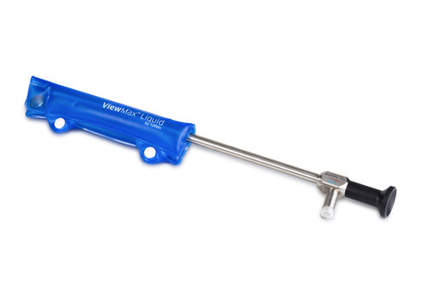

**Code: TC65LSWM (Pack of 30)**

The ViewMax™ Liquid scope warmer is an individually packaged, self contained, sterile device. Place the scope in the warmer, snap the two poppers together and activate by pressing on the metal button in the lower outer corner. Leave for two minutes and the scope will heat up to body temperature. The warm laproscope or endoscope will help prevent lens condensation.

Thanks to its convenient popper fastening no tapes are required, speeding up procedures whilst reducing costs.

ViewMax™ Liquid is around two thirds smaller than conventional liquid scope warmers. This is because warming any more than the first 7 inches of the scope is a needless exercise due to the depth that the scope will go to during any procedure. This means it achieves the same result but offers a significant saving due to less material being used.

* Simple activation.
* Self contained, sterile device.
* Heats the scope within 2 minutes.
* Can be used with all lengths and sizes of scopes.
* No longer need to use gels or wipes to clear lense.
* No electricial connections or batteries.
* No longer need to steralise/autoclave flask/bottle and stand.
* No need to fill flask/bottle.

**ViewMax™ Liquid by Toffeln - use less material and time in preparing scope for use.**



**Phone: 01 2015797 Email info@hhproducts.ie**